04-06-2020:

AWS :

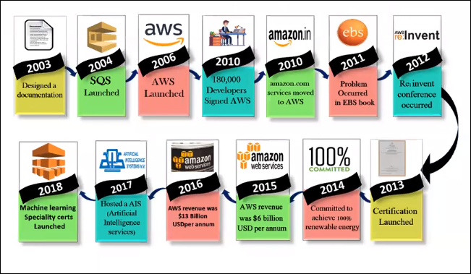

How it got started,

AWS : Amazon Web Services :

2003 : Chris Pinkman and Benjamin black.. Written whitepapers :

2004 : SQS : Simple Queue Service :

2006 : AWS Officially Launched.. :

2012 : Started annual conference.. Re: Invent.. ( here they will re conduct the meeting in los vegas, at every Nov last week or Dec first week)

2010: they had 180k developers, what even amazon.com currently we are using , it entire workload moved to AWS Cloud in the same year.

2011: we have issues with ebs service blocks.

Amazon CEO ( Jeff bejos) is different and AWS CEO ( Andy Jessy) is different.

So AWS CEO will give the keynotes in the Re: Invent session, if they want to reinvent any new features, or services, services evaluations, most of the time they use this platform to announce this stuff.

2015: generated a 6 billion $ revenue and got doubled in 2016 i.e., 13 billon$.

2017: hosted AI service.

2018: Machine learning Service.

2019: Robomaker, Ground statilite,

Why every organization is going with AWS is, it is adaptable to market.

We have lot of services which can be seen in the AWS,

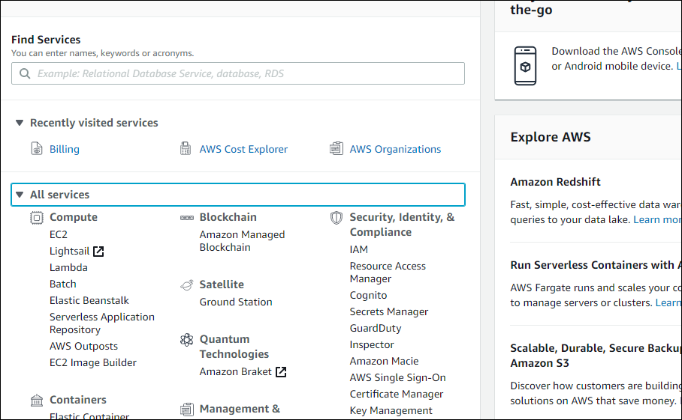

First easy to adopt, and available in the market for all services compared to other cloud vendors like Asure ( 2010 in market), GCP (2008).

So to come to the conclusion that AWS is best compared we can get the details from one the organization who do survey for all cloud computing.

<https://www.gartner.com/doc/reprints?id=1-1CMAPXNO&ct=190709&st=sb>

<https://aws.amazon.com/resources/analyst-reports/?analyst-reports-main.sort-by=item.additionalFields.datePublished&analyst-reports-main.sort-order=desc>

<https://pages.awscloud.com/Gartner-Magic-Quadrant-for-Infrastructure-as-a-Service-Worldwide.html?trk=ar_carousel>

Here we don’t have any subscription policy, here only pay as u go is the service which we utilize it.

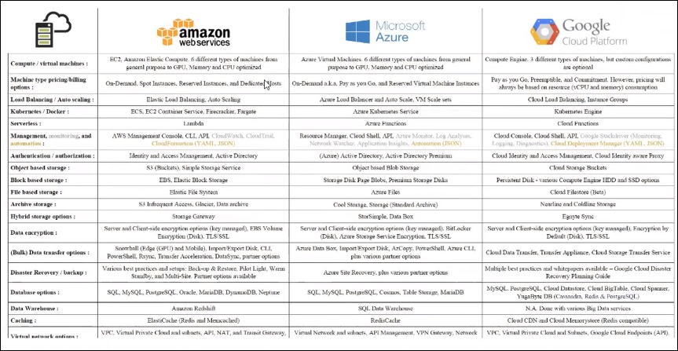

This cloud spread sheet,

What is the use of load balancer: it is distribute the load traffic to multiple servers.

If we are familiar with AWS we can easily learn Azure and GCP.

Only small UI and security features are changed when compared with AWS to Azure.

Now come to technical thing:

**Global Infrastructure** which is useful for certification part. Here to launch the servers,

Amazon divided entire the world into different region. Which is geo graphic location?

In region there is no servers or resources are running.

It will run in availability Zone (A-Z). It is a data center. It may be combination of multiple data centers. SO here actual hardware will be happened here.

<https://aws.amazon.com/about-aws/global-infrastructure/> ------ here we can see the total services and Avaiablibity of Regions, Zones,

Global Infrastructure :

Region : No technical Defination for region.. It's a Geographic / Physical locations..

24 Regions..

--> Every region contains Min of 2 AZs..

Out of 24.. 20 for all users usage..

2 Regions --> China (NWCD & Sinnet)

2 Regions --> USGovCloud (SignUP from root account)

Amazon has designed based on the standards of HIPAA , for USA govnt. And we have FedRAMP compliance.

Availability Zone / AZs : Data Centre or Combination of multiple DCs.. 76 AZs.. One AZ failure will not effect any other AZs operations.. These are desgined to isolate the individual resource failures..

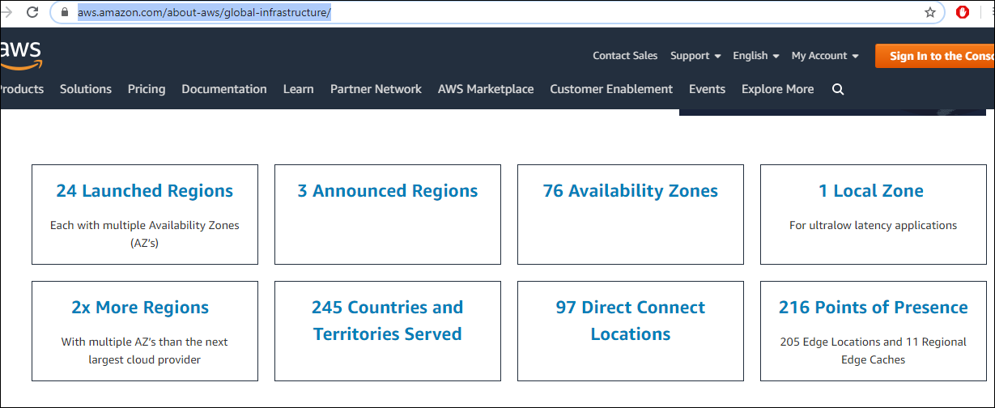

Evey region contains minium two (2) of A-Z’s and these A-z’s are interconnected with multiple internet network connectivity’s.

We will see in pictorial representation.

Let us take an example of Mumbai (ap-south-1) region. Here “ (ap-south-1) “ is the region code.

And Avaibility Zone is “(ap-south-1a) “ can be named.

Coz of this connectivity there is zero lag, coz if one fails other is there to support.

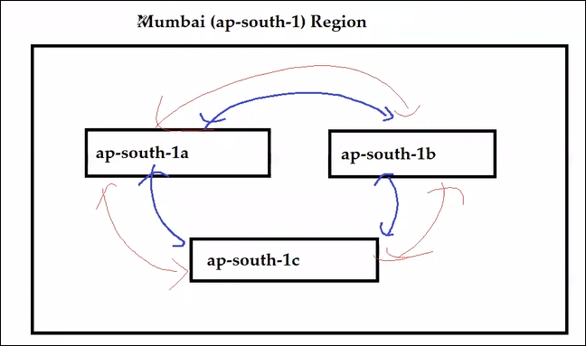

That ap-south-1a can be one data center or multiple data centers. If one A-Z is down there is no effect on the other coz Amazon maintaince miles betwn this data centers ( ap-south-1a) ----miles----(ap-south-1b).

We can run the work load in multiple regiosn also, suppose Mumbai region is down, we can use USA region to run the work load.

Where can we see the regios list and how many?

Here

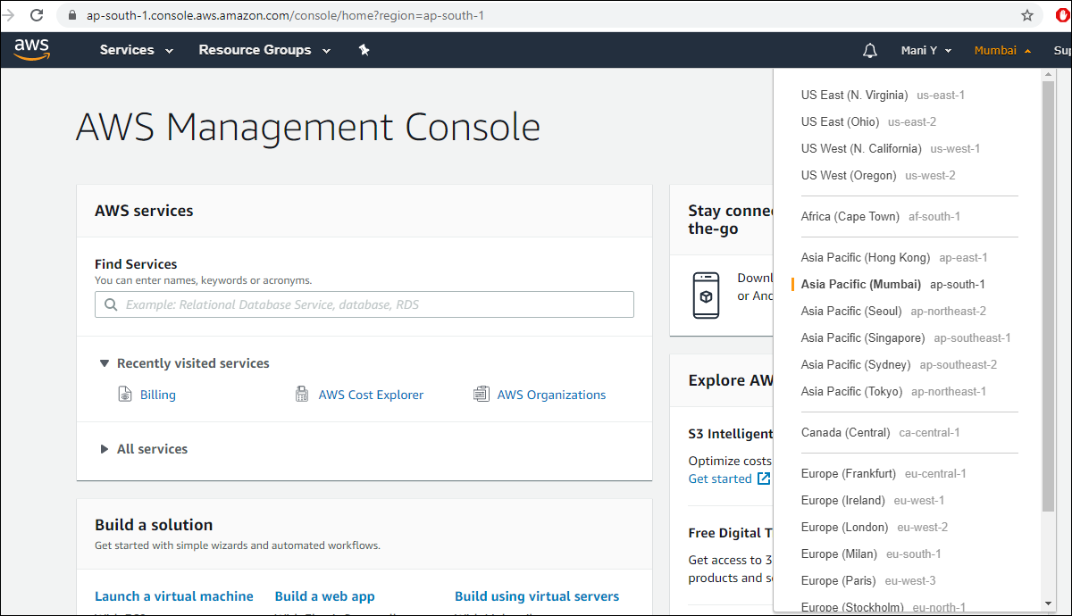

I want to launch a server in Mumbai, ec2 is a place where we can launch/run a server.

S3 is a storage.

Now we are going to launch the server. it means technically we can say they launched server can run in one of the A-Z fo Mumbai region.

We can choose the Availability Zones as per our specifications.

Suppose we have an application installed in one of the sever in Mumbai A-Z (ap-south-1a), user in Hyd try to access it, he got the respond immediately. But the same app some other user is operating it from Australia which is geographically far compared to user1, might have delay in the respond.

The delay in respond is technically called as Latency.

TO reduce that **latency ,** Amazon has come up with another resource is called as “Edge location” .

How can we say there is delay in different websites?

By using Command prompt .

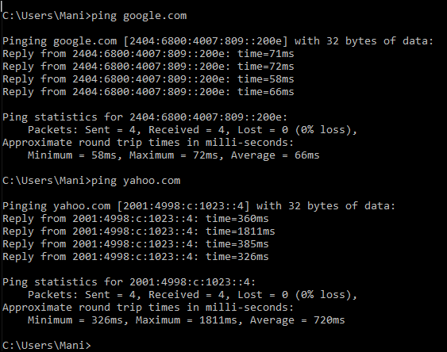

So here if we need to know the traffic how it is following to get the response,

Use bellow command: for windows [ tracert google.com]

For linux : [ traceroute google.com]

PoP (Point of Presence) / Edge Locations : CLoudfront: CDN Endpoint (Content Delivery network).. 210+ Edge..